Six reasons why criticism is a good thing
Whether it's from an audience member, freelance arts worker or museum gift shop customer, criticism can be a good thing, says Mark Thomas
Creative Boom and Mark Thomas, part of the Guardian Culture Professionals Network
Thu 9 Feb 2012
The Guardian
https://www.theguardian.com/culture-professionals-network/culture-professionals-blog/2012/feb/09/reasons-tips-criticism-arts

Listen carefully to criticism - sometimes you can use it to give you a competitive edge, says Mark Thomas.

Taking criticism can be a difficult thing. At some point in this arts world so dependant on reviews and opinions, you will encounter a customer or audience member – maybe even a reviewer – who wants to tell you how to do things better. It can be hard to deal with; after all, nobody likes to be told they're wrong. But it's not all bad news because sometimes you can use criticism to give you a competitive edge.

Criticism is a form of communication
If someone has criticism it means they want to give you feedback on what you're doing for them – that means an opportunity to learn more about the person who you're working for and how to convert them into a satisfied customer or audience member. Take a moment to think before you respond to what they're saying – in business, working with someone who is patient and able to receive and act on criticism means both parties can work towards a better outcome. For a play or production, it might mean getting to know what your audience actually want.

Feedback helps make your product stronger
If you always think you're right but don't get feedback from anyone else, how do you know for sure that what you're doing is any good? Whether you're selling or performing, whether it's a product or service, listening and acting on those honest views will tell you precisely what's good and what can be done better. Use that information to change your performance, service, exhibition or event – sometimes it will make for uncomfortable listening but it can make your product stronger as a result.

It forces you to think about how you work
Constructive criticism can guide you away from bad practices and towards good ones. Try to be objective and look at what you're providing as though it's not yours. This can be particularly difficult when you're deeply involved in a project but, if you can take a step back, you might see how to improve your way of working and avoid any negative outcomes down the road. Did you need a more specific brief? Was there something you missed in the early stages of the project? Is the performance deadline too unrealistic?

The right kind of criticism can give you an advantage
Think about it: if you can get a customer to tell you – and just you – how to give them the perfect product or service, that's information you've got that no one else has. That puts you at an advantage over anyone else in your sector and can be used again in the future to get things right, even faster. Find ways to squeeze that information from your client or audience and get them to tell you what they really want.

Use positive language, elicit a solution
The language you use in response to criticism is vitally important. Try to avoid getting into an argument. Instead, turn the exchange into a discussion about how to resolve the problem. This way you're still in a position to get paid and you'll waste less time guessing how to put things right. Consider phrases like:

"OK, so you'd like to see this design changed – what would you say is the main thing that ought to be different?"
"I can see why you say that. Let me tell you why I did it this way."
"I've thought about what you said and what I'm going to do is..."
Turn your words into action to show that you can listen to feedback, respond in the correct way and still get the job done.

Don't take it personally
Don't take it personally if someone doesn't immediately like your work. Even if you feel you're being criticised unfairly, don't retaliate with an extreme knee-jerk reaction or else you can irreparably damage your prospect of working with that client or audience and can even harm your reputation as well.
There will be occasions when you feel the criticism is personal and, now and then, you'll be right. People are fallible and it's important to remember to not be offended by someone's remarks. However, a good professional is able to take criticism on board and not respond as though it's a personal attack. They are also able to make it work to their advantage or, if all else fails, politely conclude the partnership and leave with their reputation intact.

Why criticism is good for you (and when it’s not)
CAREER ADVICE | DECEMBER 5, 2016
By: Get Smarter
https://www.getsmarter.com/blog/career-advice/why-criticism-is-good-for-you-and-when-its-not-2/

Nobody likes to be told that something they have slaved over for days didn’t quite hit the mark. And even if you know some of your work probably deserved some extra love, criticism always stings.
So, what’s the deal with criticism? Is it a necessary evil for effective communication and professional growth, or is it merely someone else’s way of feeling better about themselves?

The skill with which you communicate less-than-favourable feedback on someone’s work could mean the difference between breaking a colleague.
Here are a few ways constructive criticism it can help you, and some advice on when to let it go.

Understanding the Difference Between Criticism and Feedback
The difference between helpful and hurtful is understanding whether you are providing criticism or feedback. When you provide feedback you are coaching someone, ensuring they improve themselves. Delivering criticism on the other hand, leaves people feeling incompetent.

Unsure of how effectively you’re communicating? Transform your critical phrases into feedback that inspires change. Here are word-for-word examples of how to optimise your communication:
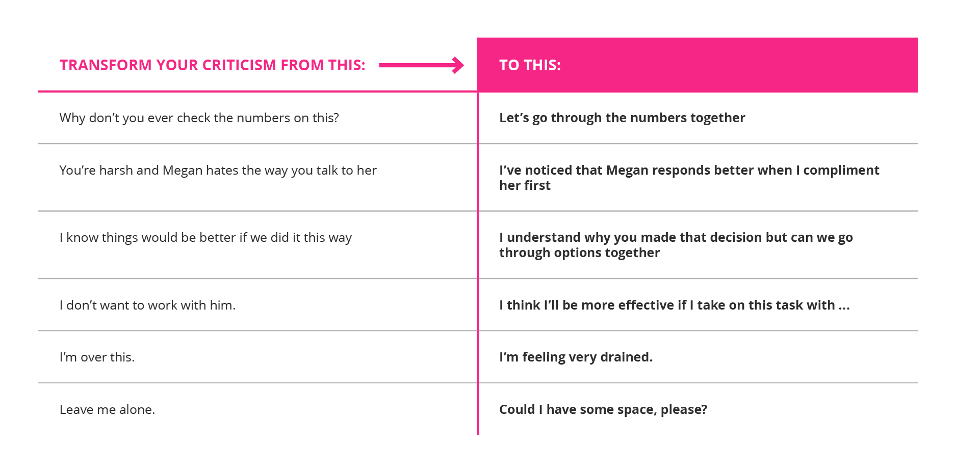

4 Reasons to Listen to the Critics
1. It’ll help you understand the ways your work could be improved
No one is perfect. The only way to know where you could improve is to encourage an open channel of communication. If you are open to suggestions around how you might approach things differently, you’ll be perceived as a more authentic leader and it’ll be easier for you to rally a team around a common goal or towards improving shared processes.

2. It’ll give you new perspective
When you’re working on the same project for long periods of time, chances are you’ll lose sight of things that aren’t working. Inviting feedback into your project will help you gain a fresh pair of eyes and improve the way forward.

3. It’s a sign that people are genuinely invested in your growth
Remember, giving someone negative feedback is almost as hard as being on the receiving end. You know what you’re saying is going to hurt the person but you do it anyway. If people didn’t care about your success, they wouldn’t waste their time trying to improve the way you work. Hear what they have to say – they could be the difference between success or failure.

4. It’ll teach you a lot about yourself and other people
How do you react when someone starts with negative feedback? Receiving criticism helps you learn about areas of your work that could be improved but it also helps you manage your own emotional reactions, helping you improve your leadership qualities.

On top of this, you’re also gifted insight into the other person. What upsets them? How do they approach difficult situations? This will improve your relationship with them as you find effective ways of communicating with them and work towards shared goals.
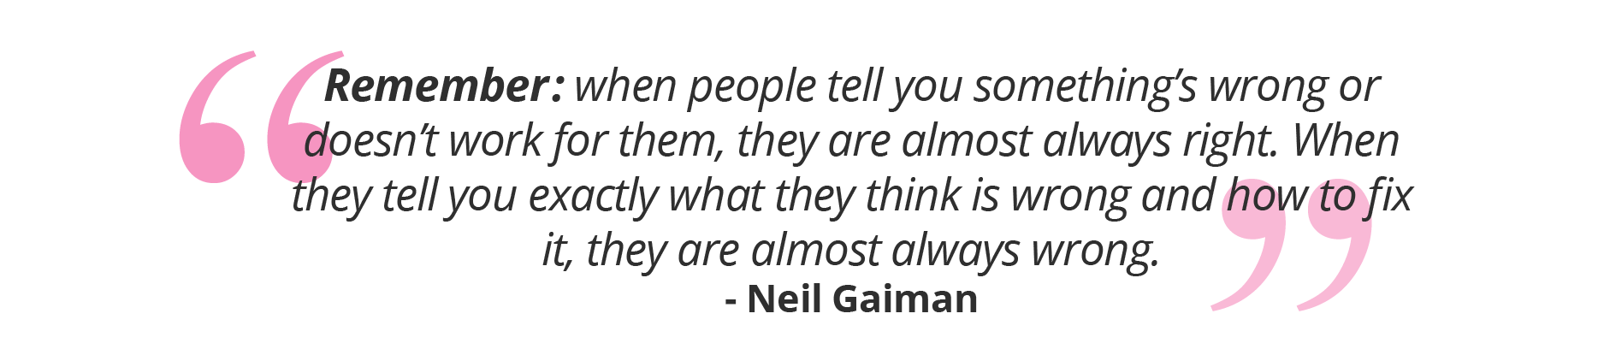
When someone points out something that’s not working, hear them out. External eyes on a project can help you solve problems you weren’t even aware existed. But, don’t take everything you’re told at face-value. You know the project you’re working on better than anyone else. Their solution might not be what you need but alerting you to the problem could help you succeed.

When to Let it Go
The most powerful tool you have in your arsenal when it comes to communication? Silence. When you listen to other people, you’re able to get the most out of what they have to say. It also proves that you take them seriously. But how do you know when criticism is not worth your time or when to take it with a pinch of salt?

1. If it makes you unhappy for a prolonged period of time
You work hard. It hurts to when someone points out your flaws, but usually you can handle it. If the feedback you are getting is something that you’ve worked to change but haven’t been able to, and the fear of it is holding you back, it’s better to let it go. The prolonged unhappiness it brings you is more detrimental to your success than a flaw someone else has pointed out.

2. If it’s too personal
Not everyone has pure motives when it comes to giving you feedback. If the criticism you’re receiving really stings, think about what that person is saying. Are they talking about something that directly influences the way you work or your behaviour in a specific situation? Or are they more concerned about you come off as a person? If feedback is based on something intrinsic to your personality, it’s not important enough to worry about.

If it’s not impacting the bottom line of the business, it’s none of their business.

3. If they aren’t providing solutions
Criticism needs to be partnered with a solution to help you correct the situation. If it’s not, the person is not interested in the success of the project enough to warrant getting involved. Ask the person providing you with feedback for their advice before you worry about solving the issue alone.

A Manager’s Guide to Providing Constructive Criticism in the Workplace
Posted March 29, 2017
By: Alvernia University
https://online.alvernia.edu/articles/constructive-criticism-in-the-workplace/

Constructive criticism in the workplace can help employees understand what they are doing well and what they need help with. Benefits include professional development, clarified expectations, stronger working relationships and overall organizational growth.

Workers understand the value of constructive criticism — and they even prefer it to praise and congratulatory comments. By a three to one margin, respondents in a Harvard Business Review study believe that constructive criticism does more to improve their performance than positive feedback. More respondents (57 percent) prefer receiving constructive criticism over positive feedback (43 percent).
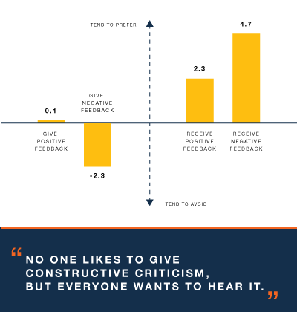Source: adapted from Harvard Business Review

Despite the benefits of and desire to receive constructive criticism in the workplace, the study revealed that managers and leaders strongly dislike giving this type of feedback. The following tips can make this process as simple and effective as possible.

7 Tips for Giving Constructive Criticism

Avoid Surprises
A meeting without notice can cause employees to feel intimidated and catch them off-guard when you provide feedback. Schedule a meeting and explain what you want to talk about. This will give the employee some notice and time to prepare.

Keep It Private
Don’t provide individual feedback in a group setting. Giving constructive criticism in the workplace should be done privately, so that the employee doesn’t feel singled out and you have the time to work through the feedback. Public and rushed displays of feedback blur the line and can lead to destructive criticism.

Be Specific
Clear and specific feedback is critical. Get to the point quickly to avoid confusing the employee. Illustrate problematic behaviors and actions so the employee has a good idea of what you are bringing up.

Don’t Make It Personal
“Focus on actions, not the person,” Charlie Harary says in Entrepreneur. You should be focusing on what the employee is doing and how to improve, not the employee’s personality. For instance, there is a difference between calling an employee disorganized and pointing out how the employee isn’t as structured as needed. The former makes an assumption about the person.

Don’t Forget the Positive
When it is relevant to your feedback, you should include positive aspects of the employee’s performance. By highlighting an employee’s strengths, you can help the worker understand what he or she is doing well while pointing out areas of improvement. All of this forms a cohesive unit of feedback for a specific topic.
Beware of including positive feedback for the sake of keeping things positive. Positive feedback can help the employee become more receptive to constructive criticism, but it should not be the reason why you offer compliments and praise. It’s similar to the rationale behind avoiding the “compliment sandwich” — or sandwiching negative feedback between two pieces of positive feedback. These strategies are an insincere way of discussing feedback with an employee.

Provide Ideas for Improvement
Provide examples of the employee’s behavior and how the person could have handled the situation.
“When it comes to helping an employee improve his or her performance, explaining to the employee what he or she did wrong is only half of the equation,” according to the New York City Bar Association. “It is crucial for the manager to be prepared with concrete examples of how the employee could have handled past problems better, as well as solutions for how the employee can deal with similar situations in the future.”

Make It a Conversation
Giving constructive criticism in the workplace is an opportunity to coach and guide an employee. If an employee is going to understand what you have to say and how he or she can improve, it needs to be a dialogue. The employee should be able to explain his or her side of the story and ask questions about how to improve. Sometimes you’ll learn something that will help you tailor your feedback and advice to the employee.

Jun 19, 2017,08:00am EST

15 Ways To Offer Truly Constructive Feedback
Forbes Coaches Council
Top business and career coaches from Forbes Coaches Council offer firsthand insights on leadership development & careers.
https://www.forbes.com/sites/forbescoachescouncil/2017/06/19/15-ways-to-offer-truly-constructive-feedback/#7367119b6e9b
Forbes

Whether it's positive or negative, formal or informal, any type of feedback from a supervisor or colleague can clue an employee in on where they stand performance-wise. These types of assessments are especially important when an employee is exhibiting troubling behaviors or attitudes, and the right feedback can help them improve significantly.

Unfortunately, not all "constructive criticism" is actually constructive. Framing and delivering your feedback the wrong way can make the recipient feel personally attacked, which only leads to defensiveness, hurt feelings and ultimately, demotivation.

Fifteen members of Forbes Coaches Council each share one key communication strategy that results in useful, constructive feedback, rather than useless or harmful criticism.
Members of Forbes Coaches Council discuss how to deliver feedback to your team in a useful and positive way.

1. Focus On How To Change
Criticism can be constructive when it is framed appropriately. Frame it in a way that the focus is on the change that needs to occur without resorting to accusations or derogatory tone and comments. Frame the criticism to include the benefit to the person making that change. Change the focus from "you" to "how" to help deliver the message. - Gia Ganesh, Gia Ganesh Coaching

2. Ground Your Constructive Criticism In Behavior
Constructive criticism clearly describes the behavior that you want changed. Instead of telling the other person that they are irresponsible, provide the dates when they have come in late. Rather than saying they are disrespectful, reference how they roll their eyes and sigh. Instead of saying you want them to be more of a "team player," explain the specific behavior that you expect. - Loren Margolis, Training & Leadership Success LLC

3. Give Your Intention Some Attention
Think about why you feel the need to share the criticism. If it's truly to help someone improve performance, approach it from a place of how you would want the information communicated to you. Stay factual to avoid an emotional confrontation and make sure you create the space for it to be a conversation (versus a directive) that leads to a positive outcome. - Gina Gomez, Gina Gomez, Business & Life Coach

4. Point Out Opportunities, Not Faults
Don't point out faults, but opportunities for growth. Start with your intention, why you are the person to share this feedback and how you are willing to help the person learn from it. Choose a location that is confidential and provide time to clearly understand the next steps. If you are respectful and listen for their impression you can build trust by being proactive. - Meredith Moore Crosby, Leverette, Weekes & Company, Inc.

5. Have A Private Conversation
Praise in public, criticize in private. This is a general rule that has a few exceptions. If the person to whom you are giving feedback feels humiliated or embarrassed, then the criticism may have little value. When criticism is given one-on-one, with the right tone and motive, it contributes value. Constructive is the key word. - Patrick Jinks, The Jinks Perspective

6. Prepare The Recipient For Feedback
If you are giving feedback, frame it with the outcome in mind, and prepare the recipient for what's about to be said. It never hurts anyone to be told, "I need to tell you something that may be hard for you to hear." If you're on the receiving end of constructive criticism, look for the grain of truth that might be useful to help you improve your performance or results. - Karen Pery, Karen Pery Coaching + Consulting

7. Use Emotional Intelligence
Consider your emotional state before delivering criticism. Are you angry or anxious? If so, you may be initiating an attack that could backfire. Take some time to understand how the feedback you need to deliver impacts you personally. Next, consider how the feedback will impact the receiver as well as your team's productivity. Manage your emotions beforehand to obtain the desired outcome. - LaKisha Greenwade, Lucki Fit LLC

8. Build A Bridge, Don't Burn One
The intention of constructive criticism is to build and strengthen a person, not tear him or her down. Focusing on the issue or the behavior and not the person will keep your conversation focused and on topic. Explain the impact the behavior had on the business. Coming from a place of collaboration and support helps keep that bridge of communication fireproof. - Joyel Crawford, Crawford Leadership Strategies

9. Start With What Is Working
Too often, we hear either "brutal honesty," or no truth at all: "Everything is great!" Real feedback is actually about telling the truth without blame or judgment - one of the four universal communication principles developed by Dr. Angeles Arrien. And the truth always has two parts: something is working, and something could be better. Start with what works, then share the upgrade. - Doy Charnsupharindr, Berkley Executive Coaching Institute

10. Know When To Get To The Point
One of the biggest misconceptions about constructive criticism is that you must wedge your critique between a positive opening and ending. However, this method of being excessively sentimental is sometimes a recipe for continued poor performance. There are times when a leader should get straight to the point and offer guidance on how flaws can be overcome. - Dionne Mahaffey, The CPAI Group, Inc

11. Focus on a Behavior That Can Be Changed
Most people give feedback by making broad-based claims without providing evidence. For example, "You're not prepared," is less useful than, "You don't have materials and I can tell you haven't practiced." Broad-based claims are interpreted as evaluations character and tend to be harmful. Constructive criticism highlights things can be changed and provides some indication of how to change them. - Ross Blankenship, PhD, Spencer Stuart

12. Maintain Collaborative Communication
If a colleague brings up an idea and you disagree with it, don’t shoot the idea down – which might be your first instinct. A quick, harsh response could shut down your channel of communication, not to mention make your colleague less likely to share ideas in the future. Focus on building a culture of collaboration to encourage constructive criticism, rather than quick objections. - Andy Bailey, Petra Coach

13. Discuss Behavior, Impact And Action
Constructive criticism describes the impact of a specific behavior. It does not focus on personality or perceived intent. It might sound like this: "You did not submit your project on time (behavior), and we had to postpone our team meeting (impact). Next time, let me know you will be late so we can plan accordingly (action)." Result? Less hurt feelings. - Kathleen Taylor-Gadsby, KTG Leadership Solutions

14. Use Criticism Well
Criticism is inherently neither constructive nor destructive. It's just information. If you use that criticism to bash yourself or undermine your self-esteem, it will be harmful. If you dismiss criticism out of hand – without examining it for the value – it will be useless. But if you assess criticism objectively and without emotion, you can discover what's useful to you, and shrug the rest off. - Debra Russell, Debra Russell Coaching, LLC

15. Show Respect And Stay Objective
Constructive criticism starts with respect for the person’s dignity. Choose words carefully. Select those that do not put the receiver on the defensive. Use "I" messages, like “I’ve noticed” or “I’m concerned about,” rather than "you" messages, like “you always” or “you never.” Keep your emotions out of it, as they can derail your message. Maintain dignity by giving choices where possible. - Judy Nelson, Judy Nelson Executive

5 Steps to Providing Constructive Criticism
Charlie Harary, GUEST WRITER
RXR Realty: Senior Director, Capital Markets
Opinions expressed by Entrepreneur contributors are their own.
August 18, 2015
Entrepreneur
https://www.entrepreneur.com/article/248110

At some point, we’ve all watched in horror as our co-worker completely messed up a project, then turned to us to ask, “So, how did I do?”
In these situations, once we overcome that initial desire to answer a nonexistent phone call, we are faced with a decision: tell them the truth, in whatever brusque, critical manner we are thinking it, or try to help out via constructive feedback.

Knowing how to give constructive criticism is one of the most important skills necessary in the business world, and in all areas of life really. People need our feedback to grow into their best selves, but if criticism is not given in the correct manner, it can be meaningless and/or destructive.
So how do you go about giving constructive criticism? I’ve developed a five-point checklist. Abide by it, and you’ll be able to turn those awkward moments into real growing experiences.

1. Time it right.
Never criticize in the moment. Nobody wants to step down from the podium and bump into a friend who says he or she spoke too quickly, his or her points were inconclusive, and the speech went on for too long. In the moment, say something nice, and then pick a better time to give advice.

2. Check yourself.
Do you really mean what you are saying, or are you using the disguise of “constructive criticism” to mask personal baggage or issues you are having with that person?

3. Use a "straw man."
If someone feels personally threatened by what you are saying, his or her defenses will go up and he or she won’t be able to internalize your criticism. Try to give the critique through a personal anecdote or an inspiring story of someone famous who went through the same thing. It’s so much easier to swallow when it’s not straight out about “you” and “your” mistakes.

4. Focus on actions, not the person.
The person is not lazy, his or her paper was just sloppy. The person is not incompetent, the editing process was just incomplete. Make sure not to focus on the person him or herself, rather on what he or she did.

5. Don’t share feedback until you need to.
If someone is about to finish a big project or speech, this is not the time to start telling him or her everything that could have been done better. Rather, wait until he or she is about to do it again. Then you can jump in with your critique, keeping in mind the previous four steps, of course.

Remember, criticism, used wrongly, can offend and threaten those around us. But used wisely, constructive criticism can be a catapult for growth and improvement.

